COURSE PLANS
Sat Jun 17 :: 695 yds
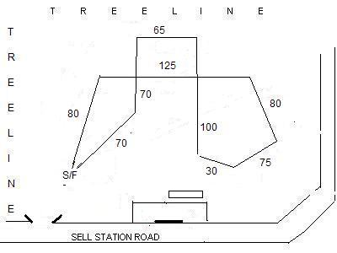

Sun Jun 18:: 710 yds
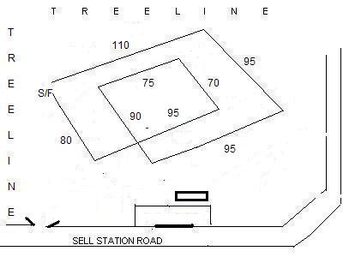

Map of area:
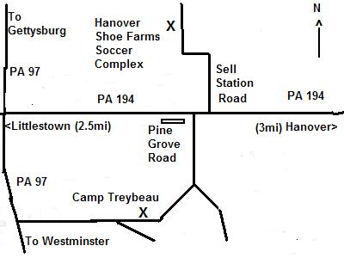

Motels: Boston Inn, Westminster, MD 800-634-0846
Days Inn, Westminster, MD 410-857-0500
Comfort Inn, Gettysburg, PA 717-337-2400
Motel 6, York, PA 717-846-6260

PREMIUM LIST
Pre-entries close 6pm, Wednesday June 14, 2006
Gate entries close 30 minutes before roll call at FTS’ desk
Cell Phone at Trial Site: (410) 868-6369

Tortoise & Hare Lure Coursers

Tortoise &Hare Lure Coursers much appreciate the generosity of Hanover Shoe Farms Inc. in permitting the use of their Soccer Complex for this event
ALL BREED LURE COURSING TESTS & TRIALS
LICENSED BY THE AMERICAN KENNEL CLUB

Saturday June 17, and Sunday June 18, 2006
Hanover Shoe Farms Soccer Complex
Sell Station Road, Hanover, PA

Pre-entry fee $18.00 for the first hound entered in trial;
$14.00 for additional hounds from the same household.
Junior Courser Test fee $16.00/hound
Late entry fees $25.00

Permission has been granted by the American Kennel Club for the holding of this event under The American Kennel Club Rules and Regulations.

Tortoise and Hare Lure Coursers - Club Officers 2006
Don Ewing………President Peter Mendecino…Vice President
Cindy VanVliet…Secretary Lori Coulson …Treasurer
Directors: Diana Itter, Peter Day, Dean Wright, Harry VanVliet

Judges and Assignments
Dr. Kammi Hefner PO Box 804, Fairmont, WV 26554
Michael Small 13593 Ridge Road, Stewartstown, PA 21102
Dean Wright 446 Baltimore Street, Hanover, PA 17331

Saturday A BA B G IB IG IW P RR SA SD W JC
K Hefner | X | X | X | X | X |  |  |  |  |  |  |  | X
M Small |  |  |  |  |  | X | X | X | X |  |  |  | X
D Wright |  |  |  |  |  |  |  |  |  | X | X | X | X

Sunday A BA B G IB IG IW P RR SA SD W JC
K Hefner |  |  |  |  |  | X | X |  |  | X | X | X | X
M Small | X | X | X | X | X |  |  |  |  |  |  |  | X
D Wright |  |  |  |  |  |  |  | X | X |  |  | X | X

FIELD COMMITTEE
Field Trial Chairman: Pete Mendecino
Field Trial Secretary: Audrey Silverstein 5529 Harpers Farm Rd. Columbia, MD 21044
Cell: (410) 868-6369 dinosmommie@yahoo.com
Records Desk & Field Clerks: Audrey Silverstein, Cindy VanVliet, Jillian VanVliet
Lure Operators: Peter Mendecino, Don Ewing, Jonathan Jordan, Chris DiNigris
Huntmasters: Bob Marciewski, Ian Davies, Sally McDowell, BethAnne Haner
Inspection Committee: Nancy Ewing, Kathy DiNigris, Diana Itter, Cindy Baker

Eligibility
Only purebred Afghan Hounds, Basenjis, Borzoi, Greyhounds, Ibizan Hounds, Italian Greyhounds, Irish Wolfhounds, Pharaoh Hounds, Rhodesian Ridgebacks, Salukis, Scottish Deerhounds, and Whippets that are one year of age or older and have been registered with The American Kennel Club or an AKC recognized foreign registry or that have been granted an Indefinite Listing Privilege (ILP) may be entered. Breed disqualifications apply.
Entries will NOT be acknowledged by mail

TRIAL HOURS 8:00AM – DUSK.
Roll Calls: Trials 8:30 am JC Tests 2:00 pm
Ribbons and Trophies
First – Blue, Second - Red, Third - Yellow, Fourth – Pink, Fifth - Green.
Best of Breed - Purple & Gold Rosette, Best in Field - Red, White & Blue Rosette
Trophies donated by T&HLC

Tests Offered
Junior Courser: Open to all eligible sighthounds. A hound running alone must receive a certification from a Judge on one date, and a second certification from a different Judge at a later date, with each Judge stating that the hound completed a (minimum) 600-yard course with a minimum of 4 turns. The hound must complete the entire course with enthusiasm and without interruption. Ribbons (Dark Green) will be awarded to all hounds that successfully complete the AKC Junior Courser Test.

Stakes Offered
OPEN: Open to all hounds of an eligible breed that have attained at least one of the following: AKC Junior Courser Title, ASFA Field Champion Title, CKC Field Champion Title, AKC Field Champion Title. Championship points may be awarded from this stake..
OPEN VETERAN: Open to all hounds, which are eligible to enter either Open or Special Stake, and are of Veteran age as determined by their Parent Breed Club. Championship or LCX points may be awarded from this stake.
SPECIAL: Open to all hounds that are eligible to enter the Open stake and have earned their AKC Field Championship titles. LCX points may be awarded from this stake.
Hounds under disqualification from AKC, ASFA or CKC Field Trials may NOT be entered.

Best in Field (BIF): Will be offered

Conditions of Entry
• All entries must be one year of age or older on the day of the trial.
• Hounds not present at the time of roll call will be scratched after a 5 minute grace period
• Stakes may be split if sufficient entries are present in any one stake at the time of the draw to support more than one 5-point Major.
• Bitches in season and lame hounds will be excused. Entries will be refunded.
• Hounds will be checked for breed disqualifications. Spayed and neutered hounds are eligible to participate. Monorchid and cryptorchid hounds are ineligible to participate.
• A $5.00 fine will be assessed for any loose hound on the field that is not competing in the course in progress.
• Battery powered, continuous loop equipment will be used. Lures consist of white plastic.
• Back-up equipment will be available.
• T&HLC reserves the right to alter course due to field and/or weather conditions on the day of the trial.
• Course will be reversed for finals, run-offs and BOB. The field is fenced; however shade is limited, and adequate shade and cooling/drinking water should be provided by participants.
• Any person may, upon reasonable complaint, be asked to leave the grounds by the Field Committee. Children MUST be under control of their parents or guardians at all times.
• Practice will be held each day upon completion of the JC.Tests; weather, field, and lure equipment permitting..

On-Call Veterinarian: 24-hour Vet Complex, Reisterstown, MD (410) 833-0500

