Course Plan Sunday, May 28 – 735 yds

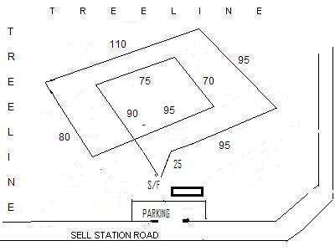

Directions to Hanover Site:
General Site Description: The Sell Station Road soccer complex is mostly fenced and is remote from busy roads. The weather may be anticipated to be warm and humid. There are woods to the south and east side of the field, but natural shade is fairly limited. Please provide adequate shade for your hounds, and bring adequate water to accommodate the conditions.
From West or South: Rt. 97 to Littlestown. At the traffic light take Rt. 194 North to Sell Station Road. Left on Sell Station; 1.3 miles to site.
From East and North: Rt. 194 South out of Hanover. Sell Station Road is 0.8 miles past the main entrance to Hanover Shoe Farms. Turn right on Sell Station; 1.3 miles to the site.

On-Call Veterinarian: 24-hour Vet Complex, Reisterstown, MD (410) 833-0500

MOTELS: Boston Inn, Westminster, MD 800-634-0846
Days Inn, Westminster, MD 410-857-0500
Comfort Inn, Westminster, MD 410-876-0010
Motel 6 (ex Red Roof), York, PA 717-846-6260

FIELD ADVISORY NEWS
The official publication of the American Sighthound Filed Association
A Bi-monthly magazine for lure coursing enthusiasts.
Subscription: BULK MAIL $30.00 per year, US residents only (Started with the next available issue; no back issues sent)
FIRST CLASS $48.00 per year (includes Canada/Mexico -
US funds only)
FOREIGN $55.00 per year (US funds or money order, please)

Send payment , payable to “ASFA” to: Field Advisory News,
Vicky Clark, editor
P.O. Box 51389, Sparks, NV 89435

PREMIUM LIST
Early Entries Close at 6pm, Wednesday, May 24, 2006
Day of Trial Entries close 30 minutes prior to Roll Call

REGION 8
MASON DIXON IBIZAN HOUND CLUB

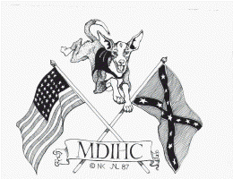
ALL BREED LURE COURSING TRIAL
LICENSED BY THE AMERICAN SIGHTHOUND FIELD ASSOCIATION
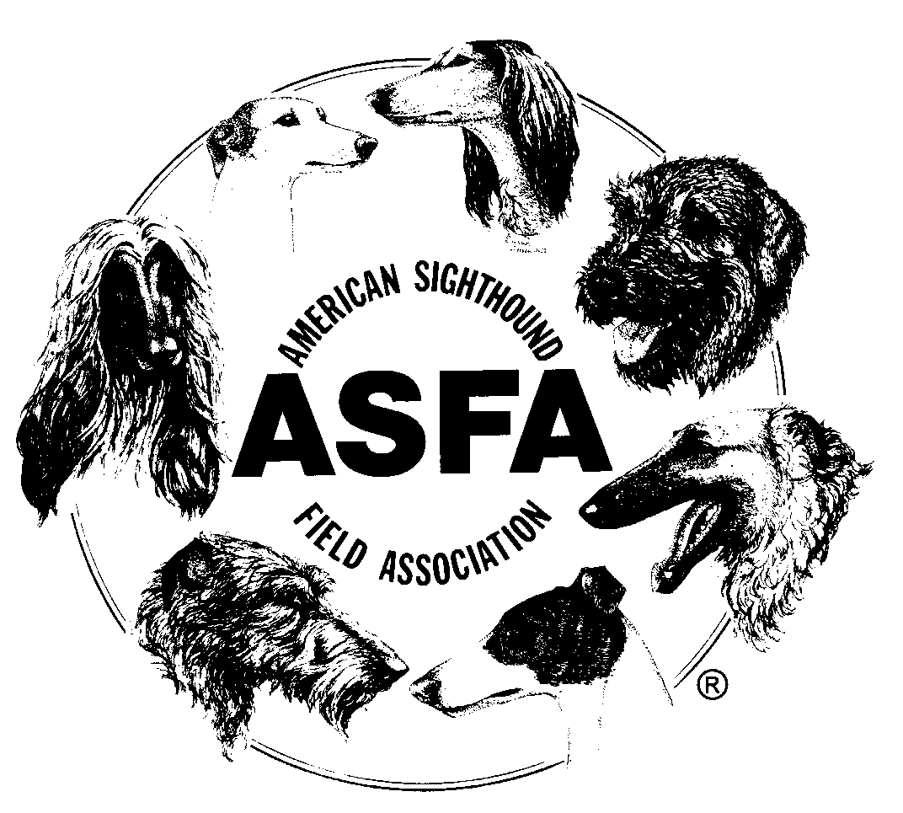
SATURDAY/SUNDAY MAY 27/28, 2006
Hanover Shoe Farms Soccer Complex,
Sell Station Rd, Hanover, PA

MDIHC again wishes to state its sincere appreciation for the ongoing generosity of Hanover Shoe Farms in permitting the use of their Soccer Complex for this event. Please show your appreciation and respect by leaving the property in the condition you found it.

Early-entry fee $18.00 for the first hound entered;
$14.00 for additional hound from the same household.

Day of Trial Entry $25.00 / Hound Certification $10

Permission has been granted by the American Sighthound Field Association for the holding of this event under ASFA Rules and Regulations

Lee Warden, Chairman, ASFA Scheduling Committee

Mason-Dixon Ibizan Hound Club - Club Officers 2005
Ian Davies…President Audrey Silverstein…Vice President
Lori Coulson…Secretary Lori Coulson …Treasurer
Directors: Peter Day, Dean Wright, Harry VanVliet

Judges and Assignments
Torrea Leborn 1228 West Street Road, West Chester, PA 19382
Camille Mendicino 4484 Nafe Sawmill Road, Glenville, PA 17329
Dean Wright 446 Baltimore Street, Hanover PA 17331
Saturday A AZ BA B G IB IG IW P RR SA SD SL W Limited
Leborn |  |  |  |  | X | X | X | X | X | X | X |  |  | X | X
Wright | X | X | X | X |  |  |  |  |  |  |  | X | X

Sunday A AZ BA B G IB IG IW P RR SA SD SL W Limited
Mendicino | X | X | X | X | X |  |  |  |  |  |  | X | X | X
Wright |  |  |  |  |  | X | X | X | X | X | X |  |  |  | X

FIELD COMMITTEE
Field Trial Chairman: Lori Coulson
Field Trial Secretary: Audrey Silverstein 5529 Harpers Farm Rd., Columbia MD 21044 (410) 868-6369 dinosmommie@yahoo.com
Records Desk & Field Clerks: Carmen Day, Audrey Silverstein, Lori Coulson
Lure Operators: Peter Mendecino, Don Ewing, Bob Jordan, Chris DiNigris
Huntmasters: Bob Marciewski, Peter Day, Beth-Anne Haner, Cindy Baker
Inspection Committee: Sally McDowell, Kathy DiNigris, Carlee Davies
Cell Phones at Trial: (410) 868-6369 / (717) 495-9454
Ribbons and Trophies
First - Blue. Second - Red, Third - yellow, fourth – white, NBQ - green.
Best of Breed - Purple & Gold Rosette, Best in Field - Red, White & Blue Rosette
Trophies offered by MDIHC
Trial Hours: 8:00am – Completion. Roll Call: 8:30 am for all breeds.
ENTRIES WILL NOT BE ACKNOWLEDGED BY MAIL
SEPARATE, DATED ENTRY FORMS ARE REQUIRED FOR EACH DAY
ELIGIBILITY
Only purebred Afghan Hounds, Azawakhs, Basenjis, Borzoi, Greyhounds, Ibizan Hounds, Italian Greyhounds, Irish Wolfhounds, Pharaoh Hounds, Rhodesian Ridgebacks, Salukis, Scottish Deerhounds, Sloughi and Whippets are eligible for competition. Limited and Provisional Stake breeds are listed in each issue of Field Advisory News. All entries shall be individually registered with the American Kennel Club, the National Greyhound Association, the Federation Cynoliguque Internationale, an ASFA-recognized foreign or ASFA board approved registry, or possess a Critique Registration Number (CRN) from the Society for the Perpetuation of the Desert-bred Saluki (SPDBS). Limited and/or Provisional Stake entries shall be individually registered with the appropriate registry.
STAKES OFFERED:
Open: Any eligible sighthound, excluding ASFA Field Champions of Record that has met certification requirements.
Field Champion: Any ASFA Field Champion.
Veteran: Any eligible hound whose age exceeds six years, except Irish Wolfhounds whose age shall exceed five years, and Whippets whose age shall be at least seven years, who has met certification requirements.
Limited Stake: Any eligible sighthound of a Limited and Provisional Stake breed, as listed in Field Advisory News, which meets certification requirements.
BEST IN FIELD WILL BE OFFERED.
Conditions of Entry: Hounds must be 1 year of age or older on the day of the trial. A stake will be split if 20 or more entries are present in any one stake at the time of the draw. All hounds will run twice, in trios if possible or braces unless excused, dismissed or disqualified. Bitches in season, hounds with breed disqualifications and lame hounds will be excused. Hounds not present at roll call will be scratched. Hound Certification runs will be offered immediately after the Saturday trial. Each entry will be examined at inspection for breed disqualifications. Spayed, neutered, cryptorchid, and monorchid hounds (without breed disqualifications) may be entered. Battery powered, continuous loop lure machines will be used. The lure will consist of white plastic strips. Backup equipment will be available. The course will be reversed for the finals, runoffs, Best of Breed and Best in Field. The members of MDIHC reserve the right to alter the course plan as required by weather and/or field conditions on the date of the trial. Exhibitors are requested to not bring bitches known to be in season to the field. There will be a $5.00 fine assessed for any loose hound not participating in the course. Any person may, upon reasonable complaint, be asked to leave the grounds by the Field Trial Committee.

Emergency Vet: 24-hour Vet Complex, Reisterstown, MD (410) 883-0500

Course Plan Saturday, May 27 – 690 yds
